EXPERIMENT 8

Experiment 8.1:
<!DOCTYPE html>
<html>
<head>
<title>Multiplication Table</title>
</head>
<body>
<h2>Multiplication Table</h2>
<label>Enter a number: </label>
<input type="number" id="num" />
<button onclick="showTable()">Show Table</button>

<div id="result"></div>

<script>
function showTable() {
let n = document.getElementById("num").value;
let output = "<h3>Table of " + n + ":</h3>";
for (let i = 1; i <= 10; i++) {
output += n + " × " + i + " = " + (n * i) + "<br>";
}
document.getElementById("result").innerHTML = output;
}
</script>
</body>
</html>

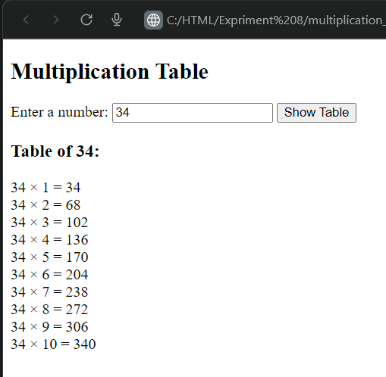

Experiment 8.2:
<!DOCTYPE html>
<html>
<head>
<title>Even Numbers 1 to 50</title>
</head>
<body>
<h2>Even Numbers from 1 to 50</h2>
<div id="output"></div>

<script>
let i = 2;
let result = "";
while (i <= 50) {
result += i + "<br>";
i += 2;
}
document.getElementById("output").innerHTML = result;
</script>
</body>
</html>

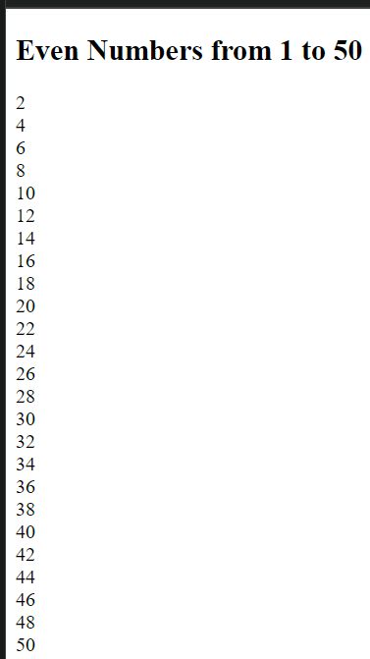
EXPERIMENT 8.3:
<!DOCTYPE html>
<html>
<head>
<title>Search Number in List</title>
</head>
<body>
<h2>Search for a Number in the List</h2>

<p>List: [10, 25, 30, 45, 50, 75, 100]</p>

<label>Enter number to search: </label>
<input type="number" id="num">
<button onclick="searchNumber()">Search</button>

<p id="result"></p>

<script>
function searchNumber() {
let arr = [10, 25, 30, 45, 50, 75, 100];
let target = parseInt(document.getElementById("num").value);
let found = false;

for (let i = 0; i < arr.length; i++) {
if (arr[i] === target) {
document.getElementById("result").innerHTML =
"Number " + target + " found at position " + (i + 1);
found = true;
break; // stop searching once found
}
}

if (!found) {
document.getElementById("result").innerHTML =
"Number " + target + " not found in the list.";
}
}
</script>
</body>
</html>

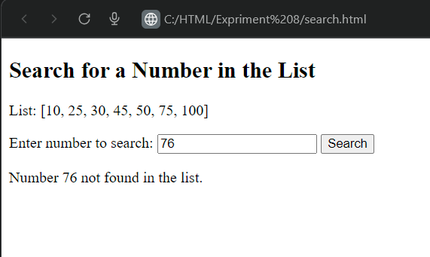

Experiment 8.4:
<!DOCTYPE html>
<html>
<head>
<title>Sum of Digits</title>
</head>
<body>
<h2>Sum of Digits using do...while Loop</h2>

<label>Enter a number: </label>
<input type="number" id="num">
<button onclick="findSum()">Find Sum</button>

<p id="result"></p>

<script>
function findSum() {
let input = document.getElementById("num").value;

// check for empty input
if (input === "") {
document.getElementById("result").innerHTML = "Please enter a number.";
return;
}

let n = Math.abs(parseInt(input)); // absolute value to avoid negative issues
let sum = 0;

do {
sum += n % 10; // take last digit
n = Math.floor(n / 10); // remove last digit
} while (n > 0);

document.getElementById("result").innerHTML = "Sum of digits: " + sum;
}
</script>
</body>
</html>

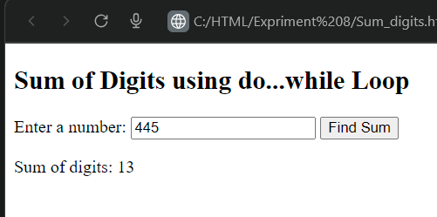
Experiment 8.5:
<!DOCTYPE html>
<html>
<head>
<title>Skip Multiples of 5</title>
</head>
<body>
<h2>Numbers from 1 to 20 (skip multiples of 5)</h2>
<div id="output"></div>

<script>
let result = "";
for (let i = 1; i <= 20; i++) {
if (i % 5 === 0) {
continue; // skip this iteration
}
result += i + "<br>";
}
document.getElementById("output").innerHTML = result;
</script>
</body>
</html>
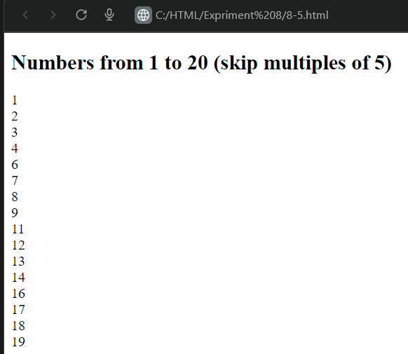

Experiment 8-6:
<!DOCTYPE html>
<html>
<head>
<title>Factorial Function</title>
</head>
<body>
<h2>Factorial Calculator</h2>
<p id="result"></p>
<script>
// Function to calculate factorial
function factorial(n) {
let fact = 1;
for (let i = 1; i <= n; i++) {
fact *= i;
}
return fact;
}

// Function to handle calculation
function calculateFactorial() {
const input = document.getElementById('numInput');
const result = document.getElementById('result');
const num = parseInt(input.value);

// Validation
if (isNaN(num) || num < 0) {
result.innerHTML = "Please enter a valid positive integer.";
return;
}

// Calculate and display
const ans = factorial(num);
result.innerHTML = `Factorial of ${num} is ${ans}`;
}

// Add event listener to button
document.getElementById('calculateBtn').addEventListener('click', calculateFactorial);
</script>
</body>
</html>

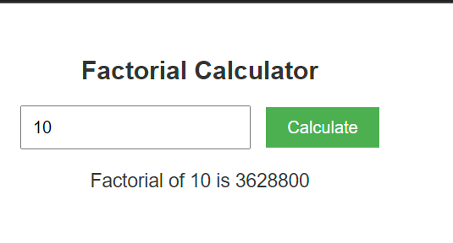

Experiment 8-7:
<!DOCTYPE html>
<html>
<head>
<title>Prime Number Check</title>
</head>
<body style="font-size:25px;">
<h2>Prime Number Checker</h2>

<label>Enter a number: </label>
<input type="number" id="num">
<button onclick="checkPrime()">Check</button>

<p id="result"></p>

<script>
function isPrime(n) {
if (n <= 1) return false;
for (let i = 2; i <= Math.sqrt(n); i++) {
if (n % i === 0) return false;
}
return true;
}

function checkPrime() {
let inputValue = document.getElementById("num").value;
let number = Number(inputValue);
if (inputValue === "" || isNaN(number)) {
document.getElementById("result").innerHTML = "Please enter a valid number.";
return;
}
let result = isPrime(number);
if (result) {
document.getElementById("result").innerHTML = number + " is a Prime Number.";
} else {
document.getElementById("result").innerHTML = number + " is NOT a Prime Number.";
}
}
</script>
</body>
</html>

